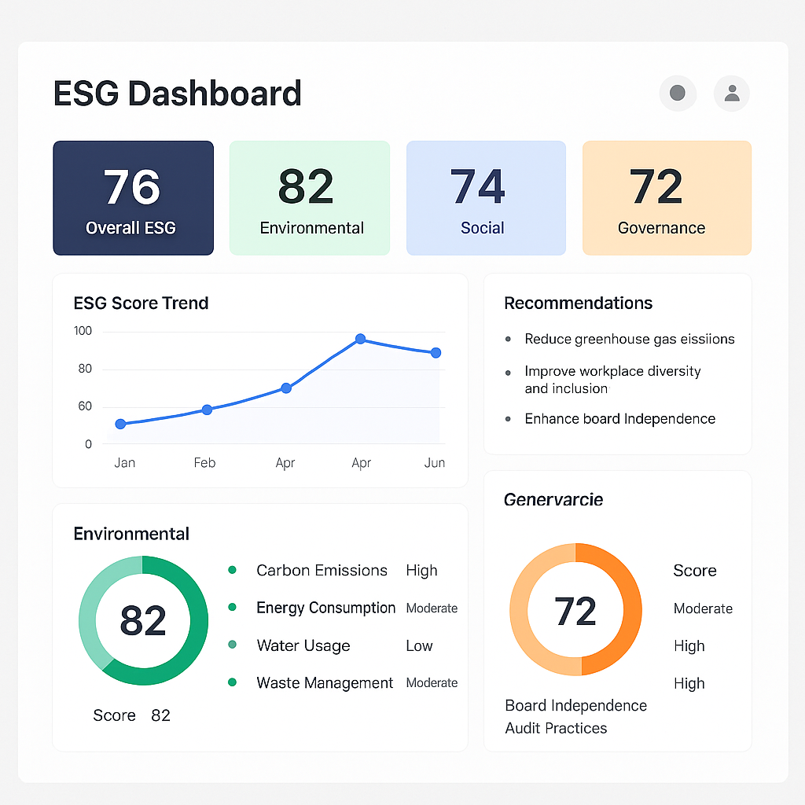

How this layout translates into your actual project
✅ 1. Top Navigation Bar
Dashboard | Companies | Reports | Settings
This is standard for SaaS apps — gives your project legitimacy.
✅ 2. ESG Score Cards (Hero Section)
Environmental | Social | Governance
Each with a circular progress ring + score.
Recruiters love this because they see analytics instantly.
✅ 3. ESG Score Trend Chart
A line graph showing how scores change over time.
This is your “data realism” moment.
✅ 4. Recommendation Panel
A small box with bullet points:
“Reduce carbon emissions…
Improve diversity…”
This makes the system feel intelligent.
✅ 5. KPI Section
Carbon Emissions
Employee Turnover
Board Independence
Having this secondary KPI zone adds depth.
✅ 6. Detailed Metric Tables
Environmental Data
Recent ESG Incidents
This is where raw numbers sit.
⭐ This is EXACTLY how a professional ESG dashboard behaves.

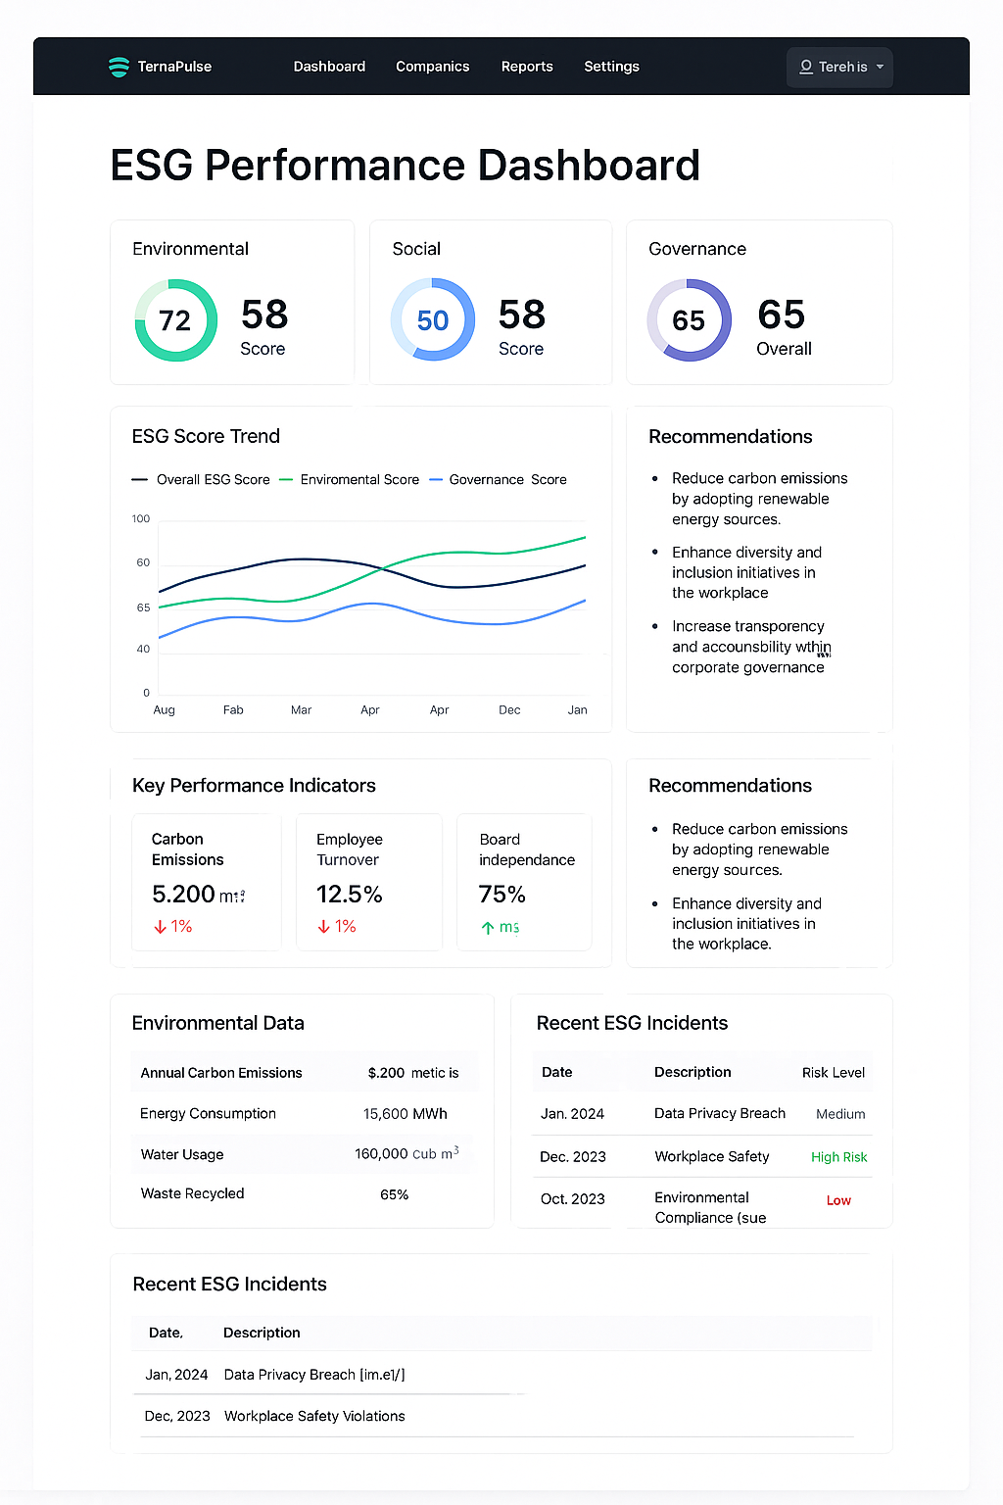

⭐ What should ideally go in the SIDEBAR?
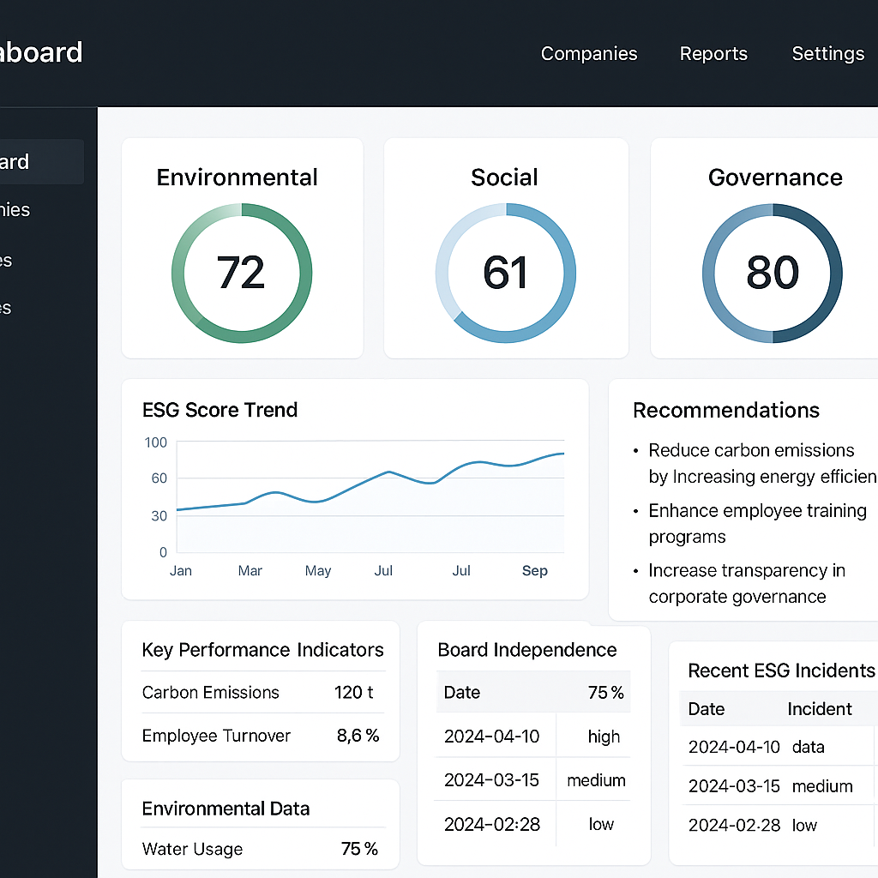
Think of the sidebar as the skeleton of your platform.
These are the sections users will visit daily.
I’ll give you a clean, professional sidebar structure:

🟩 1. Dashboard
Your main page with ESG scores, charts, KPIs, etc.

🟦 2. Companies
This opens two sub-items:
• All Companies
• Add New Company
If your project tracks multiple companies → this is essential.

🟧 3. ESG Metrics
Subsections:
• Environmental Metrics
• Social Metrics
• Governance Metrics
These pages allow detailed entry + editing of metrics.
(This matches your database schema + APIs perfectly.)

🟨 4. Score & Analysis
Sub-items:
• ESG Score Breakdown
• Trend Analysis
• Benchmarking (optional but powerful)
This is where your scoring engine shines.

🟫 5. Recommendations
Displays rule-based recommendations based on scores.
(This page gives “AI-like intelligence” without using ML.)

🟪 6. Reports
• Download ESG Report (PDF)
• Compliance Summary
• Yearly Overview
Very important if you add PDF generation.

🟫 7. Targets
Set and track sustainability targets:
• Reduce emissions
• Increase recycling
• Improve diversity
• Reduce violations
Targets make the system feel like an actual management tool.

⚙️ 8. Settings
Simple admin configurations.

⭐ What should go in the NAVBAR?
Navbar is for top-level, minimal, universal actions.
Here’s the ideal navbar:

Left side
• Logo + system name (TerraPulse / NovaESG / SustainSphere)
Right side
• Search (optional)
• Notifications icon (bell)
• Profile dropdown (name, email, logout)
That’s it.
The navbar should NOT contain feature navigation — the sidebar handles that.

⭐ Can you build the entire UI with ONLY a navbar?
Technically yes — but it’s not ideal.
Why?
If you put everything in the navbar:
• It gets cluttered.
• You lose the dashboard SaaS feeling.
• Navigation becomes horizontal and cramped.
• Recruiters see “basic website”, not “dashboard platform”.
Sidebars work because dashboards need space for complexity.
A navbar-only layout is suited for:
• simple marketing websites
• 3–4 pages max
• one-directional flows
Your ESG app is a multi-module, data-heavy system → sidebar is the right choice.

⭐ Final Answer (clean + decisive)
Use BOTH sidebar + navbar for a polished ESG SaaS.
Put feature navigation in the sidebar and user-level actions in the navbar.
Your ideal sidebar includes:
• Dashboard
• Companies
• ESG Metrics
• Score & Analysis
• Recommendations
• Reports
• Targets
• Settings
Your navbar includes:
• Logo
• Notifications
• Profile dropdown

